Changes Required

# Auction Data

Sorry, but one issue I didn’t notice in the earlier release.

1. 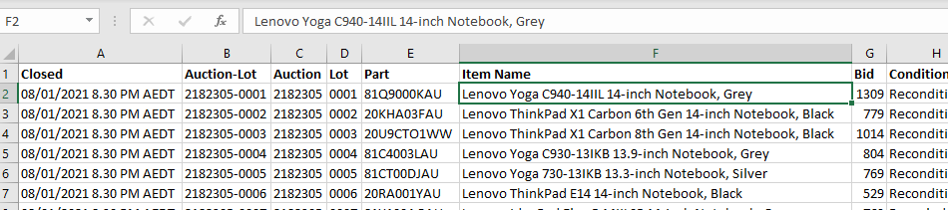Can you hyperlink the “Item Name” values to the URL, so that the selected cell in the following image will hyperlink to [www.grays.com/lot/0001-2182305](http://www.grays.com/lot/0001-2182305)